5.1 Introduction

Learning Objectives

Recognize the importance of software and its implications for the firm and strategic decision-making.

Understand that software is everywhere—not just in computers, but also cell phones, cars, cameras, and many other technologies.

Know what software is and be able to differentiate it from hardware.

List the major classifications of software and give examples of each.

We know computing hardware

The physical components of information technology, which can include the computer itself plus peripherals such as storage devices, input devices like the mouse and keyboard, output devices like monitors and printers, networking equipment, and so on.

is getting faster and cheaper, creating all sorts of exciting and disruptive opportunities for the savvy manager. But what’s really going on inside the box? It’s software

A computer program or a collection of programs. It is a precise set of instructions that tells hardware what to do.

that makes the magic of computing happen. Without software, your PC would be a heap of silicon wrapped in wires encased in plastic and metal. But it’s the instructions—the software code—that enable a computer to do something wonderful, driving the limitless possibilities of information technology.

Software is everywhere. An inexpensive “dumb” cell phone has about 1 million lines of code. Ford automobiles actually have more lines of code than Twitter and Facebook combined. Software might even be in Grandpa. The average pacemaker has between 80,000 and 100,000 lines of code. In this chapter we’ll take a peek inside the chips to understand what software is. A lot of terms are associated with software: operating systems, applications, enterprise software, distributed systems, and more. We’ll define these terms up front, and put them in a managerial context. A follow-up chapter, Chapter 6 “Software in Flux: Open Source, Cloud, Virtualized, and App-Driven Shifts”, will focus on changes impacting the software business, including open source software, software as a service (SaaS), cloud computing, virtualization, and the rise of apps. These changes are creating an environment radically different from the software industry that existed in previous decades—confronting managers with a whole new set of opportunities and challenges.

Managers who understand software can better understand the possibilities and impact of technology. They can make better decisions regarding the strategic value of IT and the potential for technology-driven savings. They can appreciate the challenges, costs, security vulnerabilities, legal and compliance issues, and limitations involved in developing and deploying technology solutions. And since firms that cannot communicate will struggle to work in tandem, managers who understand software can appreciate the key role that technology plays in partnerships, merger and acquisitions, and firm valuation. Given the pervasiveness of tech in all managerial disciplines, a firm without technologists in the boardroom is setting itself up for failure. In the next two chapters we will closely examine the software industry and discuss trends, developments and economics—all of which influence decisions managers make about products to select, firms to partner with, and firms to invest in.

What Is Software?

When we refer to computer hardware (sometimes just hardware), we’re talking about the physical components of information technology—the equipment that you can physically touch, including computers, storage devices, networking equipment, and other peripherals.

Software refers to a computer program or collection of programs—sets of instructions that tell the hardware what to do. Software gets your computer to behave like a Web browser or word processor, lets your smartphone play music and video, and enables your bank’s ATM to spit out cash.

It’s when we start to talk about the categories of software that most people’s eyes glaze over. To most folks, software is a big, incomprehensible alphabet soup of acronyms and geeky phrases: API, ERP, OS, SQL, to name just a few.

Don’t be intimidated. The basics are actually pretty easy to understand. But it’s not soup; it’s more of a layer cake. Think about computer hardware as being at the bottom of the layer cake. The next layer is the operating system

The software that controls the computer hardware and establishes standards for developing and executing applications.

, the collection of programs that control the hardware. Windows, Mac OS X, iOS, and Linux are operating systems. On top of that layer are applications

Includes desktop applications, enterprise software, utilities, and other programs that perform specific tasks for users and organizations.

—a range of which include end-user programs like those in Office, apps that run on smartphones, and the complex set of programs that manage a business’s inventory, payroll, and accounting. At the top of the cake are users.

Figure 5.1 The Hardware/Software Layer Cake

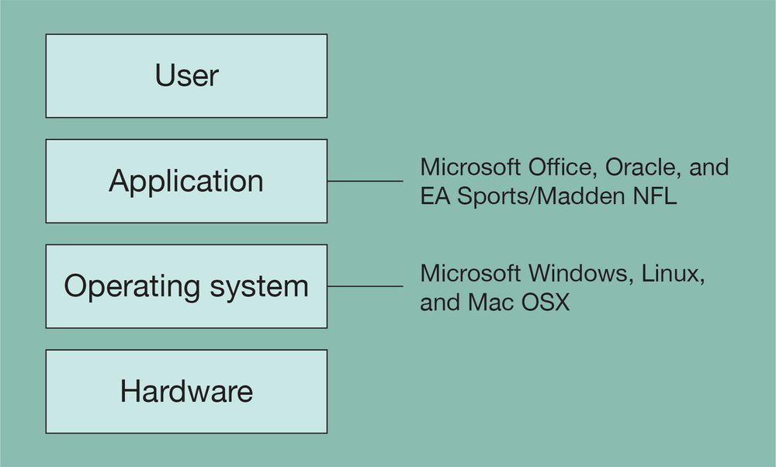

Source: John Gallaugher.

The flexibility of these layers gives computers the customization options that managers and businesses demand. Understanding how the layers relate to each other helps you make better decisions on what options are important to your unique business needs, can influence what you buy, and may have implications for everything from competitiveness to cost overruns to security breaches. What follows is a manager’s guide to the main software categories with an emphasis on why each is important.

Key Takeaways

Software refers to a computer program or collection of programs. It enables computing devices to perform tasks.

You can think of software as being part of a layer cake, with hardware at the bottom; the operating system controlling the hardware and establishing standards; the applications executing one layer up, and the users at the top.

How these layers relate to one another has managerial implications in many areas, including the flexibility in meeting business demand, costs, legal issues, and security.

Software is everywhere—not just in computers, but also in cell phones, cars, cameras, and many other technologies.

Questions and Exercises

Explain the difference between hardware and software.

Why should a manager care about software and how software works? What critical organizational and competitive factors can software influence?

What role has software played in your decision to select certain products? Has this influenced why you favored one product or service over another?

Find the Fortune 500 list online. Which firm is the highest-ranked software firm? While the Fortune 500 ranks firms according to revenue, what’s this firm’s profitability rank? What does this discrepancy tell you about the economics of software development? Why is the software business so attractive to entrepreneurs?

Refer to earlier chapters (and particularly to (Reference fwk-38086-ch02 not found in Book)): Which resources for competitive advantage might top software firms be able to leverage to ensure their continued dominance? Give examples of firms that have leveraged these assets, and why they are so strong.

5.2 Operating Systems

Learning Objectives

Understand what an operating system is and why computing devices require operating systems.

Appreciate how embedded systems extend Moore’s Law, allowing firms to create “smarter” products and services.

Computing hardware needs to be controlled, and that’s the role of the operating system. The operating system (sometimes called the “OS”) provides a common set of controls for managing computer hardware, making it easier for users to interact with computers and for programmers to write application software. Just about every computing device has an operating system—desktops and laptops, enterprise-class server computers, your mobile phone. Even specialty devices like video game consoles, television set-top boxes, Kindles, and smart applicances run some form of OS.

Some firms, like Apple and Nintendo, develop their own proprietary OS for their own hardware. Microsoft sells operating systems to everyone from Dell to the ATM manufacturer Diebold (listen for the familiar Windows error beep on some cash machines). And there are a host of specialty firms, such as Wind River (purchased by Intel), that help firms develop operating systems for all sorts of devices that don’t necessarily look like a PC, including cars, video editing systems, and fighter jet control panels.

Anyone who has used both a PC and a Mac and has noticed differences across these platforms can get a sense of the breadth of what an operating system does. Even for programs that are otherwise identical for these two systems (like the Firefox browser), subtle differences are visible. Screen elements like menus, scroll bars, and window borders look different on the Mac than they do in Windows. So do the dialogue boxes that show up when you print or save.

These items look and behave differently because each of these functions touches the hardware, and the team that developed Microsoft Windows created a system distinctly different from their Macintosh counterparts at Apple. Graphical user interface (UI)

The mechanism through which users interact with a computing device. The UI includes elements of the graphical user interface (or GUI, pronounced “gooey”), such as windows, scroll bars, buttons, menus, and dialogue boxes; and can also include other forms of interaction, such as touch screens, motion sensing controllers, or tactile devices used by the visually impaired.

items like scroll bars and menus are displayed on the hardware of the computer display. Files are saved to the hardware of a hard drive or other storage device. Most operating systems also include control panels, desktop file management, and other support programs to work directly with hardware elements like storage devices, displays, printers, and networking equipment. The Macintosh Finder and the Windows Explorer are examples of components of these operating systems. The consistent look, feel, and functionality that operating systems enforce across various programs help make it easier for users to learn new software, which reduces training costs and operator error.

Figure 5.2 Smartphone OS Market Share

Operating system market share is notoriously difficult to calculate, and a search online will reveal widely varying numbers. That said, this interactive graphic will give you a sense of the variance in major mobile operating systems worldwide: http://www.kantarworldpanel.com/global/smartphone-os-market-share/intro. A slider will allow you to compare how market share has changed.

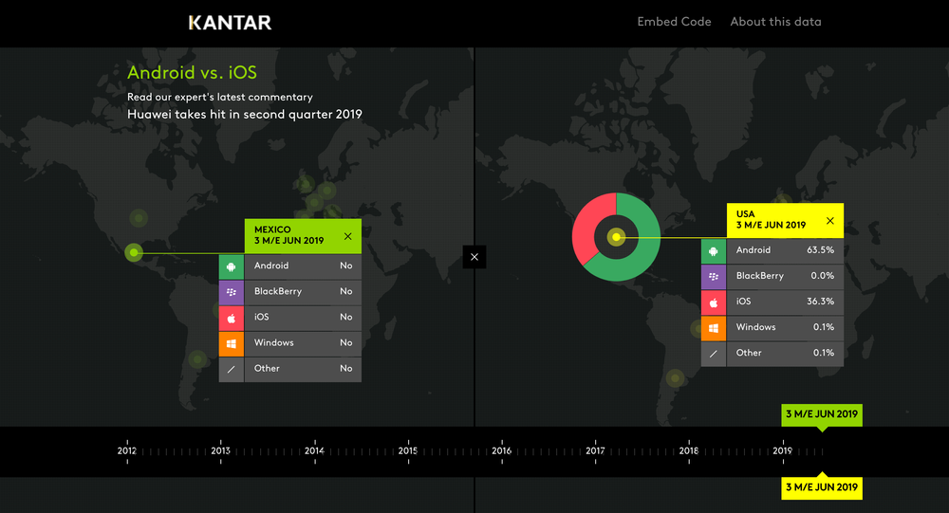

Source: Kantar World Panel, "Android vs. iOS Smartphone OS sales market share evolution." Retrieved from: http://www.kantarworldpanel.com/global/smartphone-os-market-share/.

Operating systems are also designed to give programmers a common set of commands to consistently interact with the hardware. These commands make a programmer’s job easier by reducing program complexity and making it faster to write software while minimizing the possibility of errors in code. Consider what an OS does for the game developer writing for the Nintendo Switch. Nintendo’s Switch OS provides programmers with a set of common standards to use to access the controllers, play sounds, draw graphics, save files, and more. Without this, games would be a lot more difficult to write, they’d likely look different, be less reliable, would cost more, and there would be fewer titles available.

Similarly, when Apple provided developers with a common set of robust, easy-to-use standards for the iPhone and (via the App Store) an easy way for users to install these applications on top of the iPhone/iPod touch/iPad’s operating system (iOS), software development boomed, and Apple became hands-down the most versatile mobile computing device available. In Apple’s case, some 50,000 apps became available through the App Store in less than one year, and well over 2 million apps in total are available today. A good OS and software development platform can catalyze network effects (see Chapter 3 “Platforms, Network Effects, and Competing in a Winner-Take-All World”). While the OS seems geeky, its effective design has very strategic business implications!

Firmware and Embedded Systems

Most personal computers have an operating system installed on their hard drives. This system allows the OS to be replaced or upgraded easily. But many smaller, special-purpose computing devices have their operating systems installed on nonvolatile memory, often on read-only memory (ROM) chips. Control programs stored on chips are sometimes referred to as firmware

Software stored on nonvolatile memory chips (as opposed to being stored on devices such as hard drives or removable discs). Despite the seemingly permanent nature of firmware, many products allow for firmware to be upgraded online or by connecting to another device.

. The OS in an iPad, automobile, your TV’s set-top box, and in the hardware that controls Philips Hue lightbulbs is most likely stored as firmware. Your PC also has a tiny bit of firmware that allows it to do very basic functions like start up (boot) and begin loading its operating system from disc.

Another term you might hear is embedded systems

Special-purpose software designed and included inside physical products (often on firmware). Embedded systems help make devices “smarter,” sharing usage information, helping diagnose problems, indicating maintenance schedules, providing alerts, or enabling devices to take orders from other systems.

. As computing gets cheaper, special-purpose technology is increasingly becoming embedded into all sorts of devices like cars, picture frames, aircraft engines, photocopiers, and heating and air conditioning systems. The software programs that make up embedded systems are often stored as firmware too. Using microprocessors and embedded software to enable commonly encountered devices to communicate with one another (think of the Nest thermostat or app-controlled lighting and door locks) is sometimes referred to as the Internet of Things. Embedded systems are now found in everything from herd-tracking cow collars to pipeline monitoring sensors, eliminating the need for workers to trek out and monitor operations.

Moore’s Law (see Chapter 2 “Moore's Law and More: Fast, Cheap Computing, and What This Means for the Manager”) enables embedded systems, and these systems can create real strategic value. The Otis Elevator Company, a division of United Technologies, uses embedded systems in its products to warn its service centers when the firm’s elevators, escalators, and moving walkways need maintenance or repair. This warning provides Otis with several key benefits:

Since products automatically contact Otis when they need attention, these systems generate a lucrative service business for the firm and make it more difficult for third parties to offer a competing business servicing Otis products.

Products contact service technicians to perform maintenance based on exact needs (e.g., lubricant is low, or a part has been used enough to be replaced) rather than guessed schedules, which makes service more cost-effective, products less likely to break down, and customers happier.

Any product failures are immediately detected, with embedded systems typically dispatching technicians before a client’s phone call.

The data is fed back to Otis’s R&D group, providing information on reliability and failure so that engineers can use this info to design better products.

Collectively, software embedded on tiny chips yields very big benefits, for years helping Otis remain at the top of its industry.

Key Takeaways

The operating system (OS) controls a computer’s hardware and provides a common set of commands for writing programs.

Most computing devices (enterprise-class server computers, PCs, phones, set-top boxes, video games, cars, the Mars Rover) have an operating system.

Some products use operating systems provided by commercial firms, while others develop their own operating system. Others may leverage open source alternatives (see Chapter 6 “Software in Flux: Open Source, Cloud, Virtualized, and App-Driven Shifts”).

Embedded systems are special-purpose computer systems designed to perform one or a few dedicated functions, and are frequently built into conventional products like thermostats, door locks, cars, air conditioners, industrial equipment, and elevators.

Embedded systems can make products and services more efficient, more reliable, and more functional, and can enable entire new businesses and create or reinforce resources for competitive advantage.

Questions and Exercises

What does an operating system do? Why do you need an operating system? How do operating systems make a programmer’s job easier? How do operating systems make life easier for end users?

What kinds of operating systems are used in the devices that you own? On your personal computer? Your mobile phone? The set-top box on top of your television? Are there other operating systems that you come into contact with? If you can’t tell which operating system is in each of these devices, see if you can search the Internet to find out.

For your list in the prior question (and to the extent that you can), diagram the hardware/software “layer cake” for these devices.

For this same list, do you think each device’s manufacturer wrote all of the software that you use on these devices? Can you add or modify software to all of these devices? Why or why not? What would the implications be for cost, security, complexity, reliability, updates and upgrades, and the appeal of each device?

Operating system market share is notoriously difficult to calculate. Do some research on major OS markets (PCs, tablets, smartphones, or other products). Gather data and share with your class. Is your data inconsistent with classmates’ data? Why do you suppose there are such discrepancies? Even if data are precisely inaccurate, are there rough trends that you can trust, and if so, what sorts of managerial decisions might these influence?

Which mobile OS has a larger global market share: Android or iOS? Which has returned more money to developers through its app store? Is this data what you’d expect? Why or why not?

Some ATM machines use Windows. Why would an ATM manufacturer choose to build its systems using Windows? Why might it want to avoid this? Are there other non-PC devices you’ve encountered that were running some form of Windows?

What are embedded systems? When might firms want to install software on chips instead of on a hard drive? Why are embedded systems important for the Internet of Things?

It’s important to understand how technology impacts a firm’s strategy and competitive environment. Consider the description of Otis Elevator’s use of embedded systems. Which parts of the value chain does this impact? How? Consider the “five forces”: How does the system impact the firm’s competitive environment? Are these systems a source of competitive advantage? If not, explain why not. If they are, what kinds of resources for competitive advantage can these kinds of embedded systems create?

Can you think of other firms that can or do leverage embedded systems? Provide examples and list the kinds of benefits these might offer firms and consumers.

Research the Americans with Disabilities Act of 1990 (or investigate if your nation has a similar law), and the implications of this legislation for software developers and website operators. Have firms been successfully sued when their software or websites could not be accessed by users with physical challenges? What sorts of issues should developers consider when making their products more accessible? What practices might they avoid?

5.3 Application Software: Apps, Desktop Products, and Enterprise Systems

Learning Objectives
- Appreciate the difference between desktop and enterprise software.
- List the categories of enterprise software.
- Understand what an ERP (enterprise resource planning) software package is.
- Recognize the relationship of the DBMS (database management system) to the other enterprise software systems.
- Recognize both the risks and rewards of installing packaged enterprise systems.
Operating systems are designed to create a platform
Products and services that allow for the development and integration of software products and other complementary goods. Windows, iOS, Android, and the standards that allow users to create Facebook apps are all platforms.
so that programmers can write additional applications, allowing the computer to do even more useful things. While operating systems control the hardware, application software (sometimes referred to as software applications, applications, or even just apps) performs the work that users and firms are directly interested in accomplishing. Think of applications as the place where the user’s or organization’s real work gets done. As we learned in Chapter 3 “Platforms, Network Effects, and Competing in a Winner-Take-All World”, the more application software that is available for a platform (the more games for a video game console, the more apps for your phone), the more valuable it potentially becomes.
Desktop software
Applications installed on a personal computer, typically supporting tasks performed by a single user.
refers to applications installed on a personal computer—your browser, your Office suite (e.g., word processor, spreadsheet, presentation software), photo editors, and computer games are all desktop software. Enterprise software
Applications that address the needs of multiple users throughout an organization or work group.
refers to applications that address the needs of multiple, simultaneous users in an organization or work group. Most companies run various forms of enterprise software programs to keep track of their inventory, record sales, manage payments to suppliers, cut employee paychecks, and handle other functions. Another term you might hear is apps. While the definition of apps is somewhat fluid, most folks use the term app to refer to smaller pieces of software that are designed for a specific platform, such as the programs that are executed on a smartphone, tablet, television, or specialized platform like the Apple Watch or Oculus Rift.
Some firms write their own enterprise software from scratch, but this can be time consuming and costly. Since many firms have similar procedures for accounting, finance, inventory management, and human resource functions, it often makes sense to buy a software package
A software product offered commercially by a third party.
(a software product offered commercially by a third party) to support some of these functions. So-called enterprise resource planning (ERP)
A software package that integrates the many functions (accounting, finance, inventory management, human resources, etc.) of a business.
software packages serve precisely this purpose. In the way that Microsoft can sell you a suite of desktop software programs that work together, many companies sell ERP software that coordinates and integrates many of the functions of a business. The leading ERP vendors include the firms SAP and Oracle, although there are many firms that sell ERP software, and there are ERP and other enterprise products delivered “through the cloud” to browsers or apps, requiring no back-end software to be run on-site.
A company also doesn’t have to install all of the modules of an ERP suite, but it might add functions over time—for example, to plug in an accounting program that is able to read data from the firm’s previously installed inventory management system. And although a bit more of a challenge to integrate, a firm can also mix and match components, linking software the firm has written with modules purchased from different enterprise software vendors.
Figure 5.3 ERP in Action
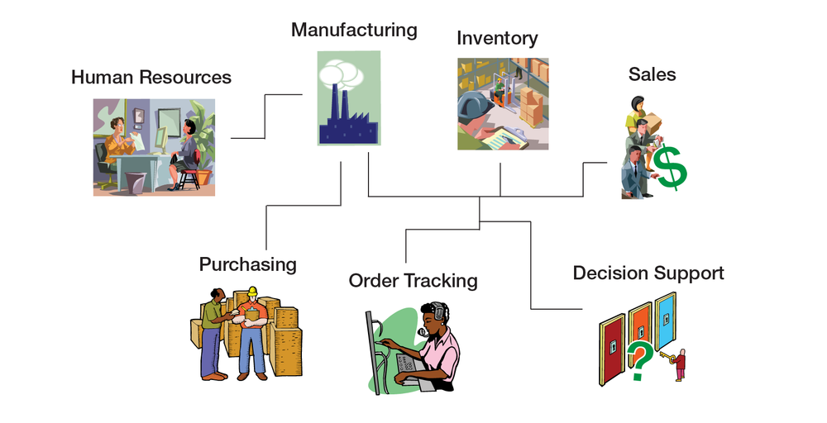
Source: Based on G. Edmondson, “Silicon Valley on the Rhine,” BusinessWeek International, November 3, 1997. Retrieved from: https://www.bloomberg.com/news/articles/1997-11-02/silicon-valley-on-the-rhine.
An ERP system with multiple modules installed can touch many functions of the business:
- Sales—A sales rep from Vermont-based SnowboardCo. takes an order for 5,000 boards from a French sporting goods chain. The system can verify credit history, apply discounts, calculate price (in euros), and print the order in French.
- Inventory—While the sales rep is on the phone with his French customer, the system immediately checks product availability, signaling that 1,000 boards are ready to be shipped from the firm’s Burlington warehouse, the other 4,000 need to be manufactured and can be delivered in two weeks from the firm’s manufacturing facility in Guangzhou.
- Manufacturing—When the customer confirms the order, the system notifies the Guangzhou factory to ramp up production for the model ordered.
- Human Resources—High demand across this week’s orders triggers a notice to the Guangzhou hiring manager, notifying her that the firm’s products are a hit and that the flood of orders coming in globally mean her factory will have to hire more workers to keep up.
- Purchasing—The system keeps track of raw material inventories, too. New orders trigger an automatic order with SnowboardCo.’s suppliers, so that raw materials are on hand to meet demand.
- Order Tracking—The French customer can log in to track her SnowboardCo. order. The system shows her other products that are available, using this as an opportunity to cross-sell additional products.
- Decision Support—Management sees the firm’s European business is booming and plans a marketing blitz for the continent, targeting board models and styles that seem to sell better for the Alps crowd than in the U.S. market.
Other categories of enterprise software that managers are likely to encounter include the following:
- customer relationship management (CRM)
- Systems used to support customer-related sales and marketing activities.
- systems used to support customer-related sales and marketing activities
- supply chain management (SCM)
- Systems that can help a firm manage aspects of its value chain, from the flow of raw materials into the firm, through delivery of finished products and services at the point-of-consumption.
- systems that can help a firm manage aspects of its value chain, from the flow of raw materials into the firm through delivery of finished products and services at the point-of-consumption
- business intelligence (BI) systems
- Systems that use data created by other systems to provide reporting and analysis for organizational decision-making.
- , which use data created by other systems to provide reporting and analysis for organizational decision-making
Major ERP vendors are now providing products that extend into these and other categories of enterprise application software, as well.
Most enterprise software works in conjunction with a database management system (DBMS)
Sometimes referred to as database software; software for creating, maintaining, and manipulating data.
, sometimes referred to as a “database system.” The database system stores and retrieves the data that an application creates and uses. Think of this as an additional layer in our cake analogy. Although the DBMS is itself considered an application, it’s often useful to think of a firm’s database systems as sitting above the operating system, but under the enterprise applications. Many ERP systems and enterprise software programs are configured to share the same database system so that an organization’s different programs can use a common, shared set of data. This system can be hugely valuable for a company’s efficiency. For example, this could allow a separate set of programs that manage an inventory and point-of-sale system to update a single set of data that tells how many products a firm has to sell and how many it has already sold—information that would also be used by the firm’s accounting and finance systems to create reports showing the firm’s sales and profits.
Firms that don’t have common database systems with consistent formats across their enterprise often struggle to efficiently manage their value chain. Common procedures and data formats created by packaged ERP systems and other categories of enterprise software also make it easier for firms to use software to coordinate programs between organizations. This coordination can lead to even more value chain efficiencies. Sell a product? Deduct it from your inventory. When inventory levels get too low, have your computer systems send a message to your supplier’s systems so that they can automatically build and ship replacement product to your firm. In many cases these messages are sent without any human interaction, reducing time and errors. And common database systems also facilitate the use of BI systems that provide critical operational and competitive knowledge and empower decision-making. For more on CRM and BI systems, and the empowering role of data, see Chapter 7 “Data and Competitive Advantage: Databases, Analytics, AI, and Machine Learning”.
Figure 5.4 Database Management System
An organization’s database management system can be set up to work with several applications both within and outside the firm.
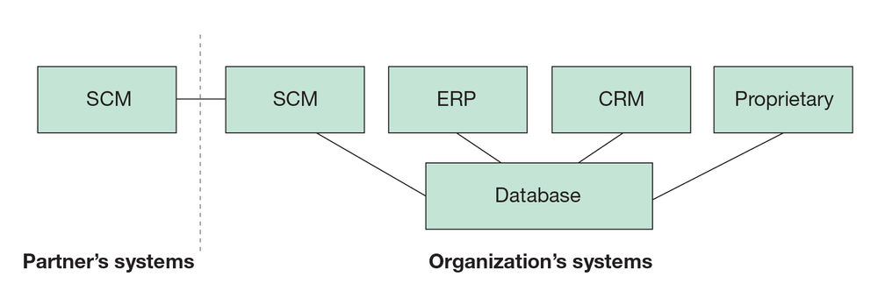
Source: John Gallaugher.

And That’s Just the Start
Be prepared for even more discussions on software categories and the changing nature of software. Future chapters will discuss additional topics, such as cloud computing—where software and other computing functions are delivered as a service through an Internet connection rather than being installed on a user or firm’s computer hardware. Many products, from hefty ERP systems (NetSuite is one leader, which Oracle has acquired) to end-user application suites (think Google Docs, Sheets, and Slides) are being delivered “via the cloud.”
You’ll also learn about additional classifications of software, including artificial intelligence and machine learning systems. These systems mimic or improve upon functions that would otherwise require human intelligence. As you continue through this book, be sure to see the connections with earlier topics, as well. The spread of software from your tiny doorbell to the massive data crunched to target advertising, is all being powered by the fast/cheap computing trends we learned about in earlier chapters.

The Rewards and Risks of Packaged Enterprise Systems
When set up properly, enterprise systems can save millions of dollars and turbocharge organizations. For example, the CIO of office equipment maker Steelcase credited the firm’s ERP with an $80 million reduction in operating expenses saved from eliminating redundant processes and making data more usable. The CIO of Colgate Palmolive also praised their ERP, saying, “The day we turned the switch on, we dropped two days out of our order-to-delivery cycle.” Packaged enterprise systems can streamline processes, make data more usable, and ease the linking of systems with software across the firm and with key business partners. Plus, the software that makes up these systems is often debugged, tested, and documented with an industrial rigor that may be difficult to match with proprietary software developed in-house.
But for all the promise of packaged solutions for standard business functions, enterprise software installations have proven difficult. Standardizing business processes in software that others can buy means that those functions are easy for competitors to match, and the vision of a single monolithic system that delivers up wondrous efficiencies has been difficult for many to achieve. The average large company spends roughly $15 million on ERP software, with some installations running into the hundreds of millions of dollars. And many of these efforts have failed disastrously.
FoxMeyer was once a $6 billion drug distributor, but a failed ERP installation led to a series of losses that bankrupted the firm. The collapse was so rapid and so complete that just a year after launching the system, the carcass of what remained of the firm was sold to a rival for less than $80 million. Hershey Foods blamed a $466 million revenue shortfall on glitches in the firm’s ERP rollout. Among the problems, the botched implementation prevented the candy maker from getting product to stores during the critical period before Halloween. Nike’s first SCM and ERP implementation was labeled a “disaster”; their systems were blamed for over $100 million in lost sales. Even tech firms aren’t immune to software implementation blunders. HP once blamed a $160 million loss on problems with its ERP systems. Manager beware—there are no silver bullets. For insight on the causes of massive software failures, and methods to improve the likelihood of success, see Chapter 5, Section 6 “Software Development Methodologies: From Waning Waterfall to Ascending Agile, plus a Sprint through Scrum” of this chapter.
Companies that have efficient, flexible information systems don’t just see value through operations efficiency and cost savings. Technology can also influence a firm’s options with respect to inter-firm partnerships, as well as merging with, acquiring, or getting acquired by other firms (M&A, or mergers and acquisitions). Firms that have systems that work smoothly internally may find it easier to partner with others. Consulting firm McKinsey suggests that many mergers don’t live up to expectations because firms struggle when trying to combine complex and incompatible information systems. Efficient and integrated enterprise systems may also make firms more attractive acquisition targets or make it easier for a firm to acquire other firms and realize the benefit from acquisition. McKinsey suggests acquired firms may be more valuable and acquirers may be justified in bidding more for acquisition targets since efficient tech may allow firms to capture the 10 to 15 percent cost savings that successful mergers can usually realize by combining IT systems. McKinsey points to Oracle as an example of a firm whose efficiency has helped it win at M&A (mergers and acquisition). Oracle, which sells ERP systems, consolidated seventy of its own information systems into a single ERP for the entire firm, saving an estimated $1 billion annually. Serious coin, but from a strategic perspective, it also created internal systems that were streamlined and simplified, making it easier to integrate acquired firms. Oracle bought over fifty firms in a four-year period and can now integrate most acquisitions in six months or less.

Key Takeaways
- Application software focuses on the work of a user or an organization.
- Desktop applications are typically designed for a single user. Enterprise software supports multiple users in an organization or work group.
- Popular categories of enterprise software include ERP (enterprise resource planning), SCM (supply chain management), CRM (customer relationship management), and BI (business intelligence) software, among many others.
- These systems are used in conjunction with database management systems, programs that help firms organize, store, retrieve, and maintain data.
- ERP and other packaged enterprise systems can be challenging and costly to implement, but can help firms create a standard set of procedures and data that can ultimately lower costs and streamline operations.
- The more application software that is available for a platform, the more valuable that platform becomes.
- The DBMS stores and retrieves the data used by the other enterprise applications. Different enterprise systems can be configured to share the same database system in order to share common data.
- Firms that don’t have common database systems with consistent formats across their enterprise often struggle to efficiently manage their value chains, and often lack the flexibility to introduce new ways of doing business. Firms with common database systems and standards often benefit from increased organizational insight and decision-making capabilities.
- Enterprise systems can cost millions of dollars in software, hardware, development, and consulting fees, and many firms have failed when attempting large-scale enterprise system integration. Simply buying a system does not guarantee its effective deployment and use.
- When set up properly, enterprise systems can save millions of dollars and turbocharge organizations by streamlining processes, making data more usable, and easing the linking of systems with software across the firm and with key business partners.
- Efficient enterprise systems may also make it easier for firms to partner with other organizations, and can give it advantages when considering mergers and acquisitions.

Questions and Exercises
- What is the difference between desktop and enterprise software?
- Who are the two leading ERP vendors?
- List the functions of a business that might be impacted by an ERP.
- What do the acronyms ERP, CRM, SCM, and BI stand for? Briefly describe what each of these enterprise systems does.
- Where in the “layer cake” analogy does the DBMS lie?
- Name two companies that have realized multimillion-dollar benefits as a result of installing enterprise systems.
- Name two companies that have suffered multimillion-dollar disasters as a result of failed enterprise system installations.
- How much does the average large company spend annually on ERP software?
- How do efficient enterprise systems help firms with respect to partnering with other organizations, as well as decisions around M&A?

5.4 Distributed Computing, Web Services, and APIs: The Platform Builders

Learning Objectives
- Understand the concept of distributed computing and its benefits.
- Understand the client-server model of distributed computing.
- Know what Web services and APIs are and the benefits that these technologies bring to firms.
- Appreciate the importance of messaging standards and understand how sending messages between machines can speed processes, cut costs, reduce errors, and enable new ways of doing business.
When computers in different locations can communicate with one another, this is often referred to as distributed computing
A form of computing where systems in different locations communicate and collaborate to complete a task.
. Distributed computing can yield enormous efficiencies in speed, error reduction, and cost savings and can create entirely new ways of doing business. Designing systems architecture for distributed systems involves many advanced technical topics. Rather than provide an exhaustive decomposition of distributed computing, the examples that follow are meant to help managers understand the bigger ideas behind some of the terms that they are likely to encounter.
Let’s start with the term server
A program that fulfills the requests of a client.
. This is a tricky one because it’s frequently used in two ways: (1) In a hardware context, a server is a computer that has been configured to support requests from other computers (e.g., Dell sells servers), and (2) in a software context, a server is a program that fulfills requests (e.g., the Apache open source Web server). Most of the time, server software resides on server-class hardware, but you can also set up a PC, laptop, or other small computer to run server software, albeit less powerfully. And you can use mainframe or supercomputer-class machines as servers, too. And as mentioned in the prior section, many firms choose not to own some of their applications or any of their own server hardware at all. Instead, they pay third-party firms to host their software “in the cloud.” This option is particularly attractive for smaller firms that can’t or don’t want to invest in the expense and expertise associated with owning and operating hardware, for firms looking for extra computing capacity, and for firms that want public servers (e.g., websites) to be in fast, reliable locations outside of a company’s own private network.
The World Wide Web, like many other distributed computing services, is what geeks call a client-server system. Client-server refers to two pieces of software: a client
A software program that makes requests of a server program.
that makes a request and a server that receives and attempts to fulfill the request. In our WWW scenario, the client is the browser (e.g., Internet Explorer, Chrome, Firefox, Safari). When you type a website’s address into the location field of your browser, you’re telling the client to “go find the Web server software at the address provided, and tell the server to return the website requested.” Smartphone and tablet apps can also act as clients that make requests of more powerful server programs running elsewhere on the Web. Another example is smartphone voice recognition software, such as Apple’s Siri. Voice recognition typically requires computing power far greater than that held on a smartphone, so Apple sends your voice to a more powerful collection of servers for processing and interpretation.
It is possible to link simple scripting languages to a Web server for performing calculations, accessing databases, or customizing websites. But more advanced distributed environments may use a category of software called an application server
Software that houses and serves business logic for use (and reuse) by multiple applications.
. The application server (or app server) houses business logic for a distributed system. Individual software components or Web services
Small pieces of code that are accessed via the application server, and permit interoperable machine-to-machine interaction over a network.
served up by the app server are programmed to perform different tasks: returning a calculation (“sales tax for your order will be $11.58”), accessing a database program (“here are the results you searched for”), or even making a request to another server in another organization (“Visa, please verify this customer’s credit card number for me”).
Figure 5.5 Multitiered Distributed System
In this multitiered distributed system, client browsers on various machines (desktop, laptop, mobile) access the system through the Web server. The cash register doesn’t use a Web browser, so instead the cash register logic is programmed to directly access the services it needs from the app server. Web services accessed from the app server may be asked to do a variety of functions, including perform calculations, access corporate databases, or even make requests from servers at other firms (for example, to verify a customer’s credit card).
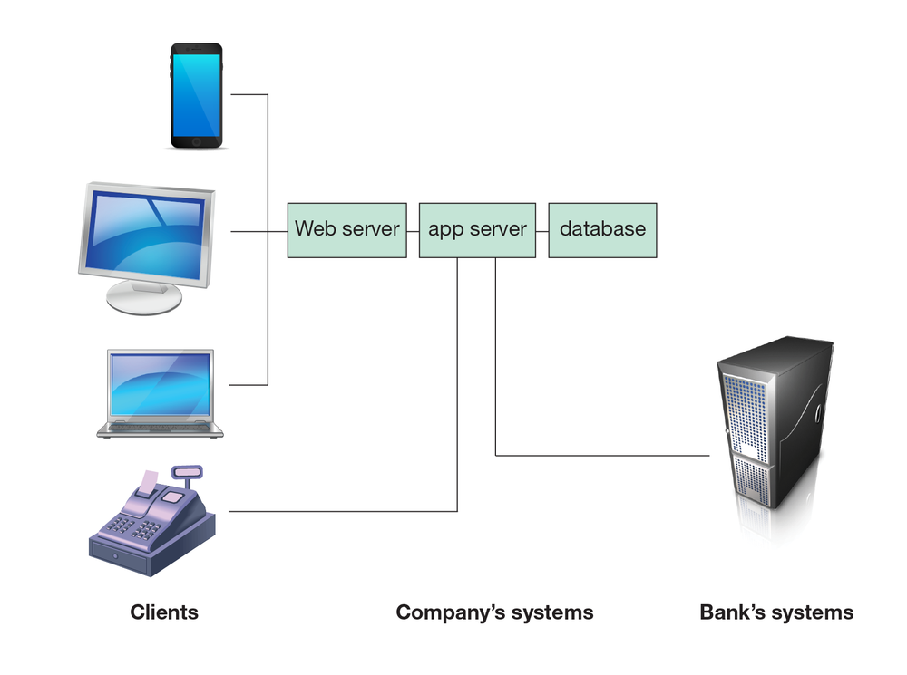
Source: John Gallaugher.
Those little chunks of code that are accessed via the application server are sometimes referred to as Web services. The World Wide Web consortium defines Web services as software systems designed to support interoperable machine-to-machine interaction over a network. You might also hear the term APIs
Programming hooks, or guidelines, published by firms that tell other programs how to get a service to perform a task such as send or receive data. For example, Amazon.com provides APIs to let developers write their own applications and websites that can send the firm orders.
(or application programming interfaces) used to describe the same concept. There are deeper technical issues that precisely define Web services and the super-set of technologies known as APIs (and even IBM says existing definitions aren’t especially precise), but for managerial purposes you can think of Web services and APIs as doing pretty much the same thing; they are referring to pieces of code, and the request/response standards so that this code be summoned by other programs to perform a task (the term API is more in vogue today, so expect to hear that more). Have you seen firms other than Google using Google Maps? They can do this because Google publishes APIs so that others can use this service. Uber’s API allowed United Airlines to build an app that can summon an Uber driver (either by deep-linking to the Uber app, or by completing a transaction over United’s website if the app isn’t installed). Spotify’s API allowed Uber to modify its app to play a rider’s playlist through the driver’s smartphone-connected car speakers. Alcohol delivery service Drizly has published an API that allows the whisky recommendation app Distiller to order booze right from Distiller screens.
Organizations that have created a robust set of Web services around their processes and procedures are said to have a service-oriented architecture (SOA)
A robust set of Web services built around an organization's processes and procedures.
. Organizing systems like this, with separate applications in charge of client presentation, business logic, and database, makes systems more flexible. Code can be reused, and each layer can be separately maintained, upgraded, or migrated to new hardware—all with little impact on the others. And firms that invite other organizations to integrate with their systems via Web services and APIs are often thought of as turning their products into platforms
Products and services that allow for the development and integration of software products and other complementary goods. Windows, the iPhone, the Wii, and the standards that allow users to create Facebook apps are all platforms.
. Firms that create platforms have the potential to make their products and services more useful, widen their reach, create switching costs, and enhance network effects (for more on this, see Chapter 3 “Platforms, Network Effects, and Competing in a Winner-Take-All World”).
Figure 5.6 Expedia Affiliate Network
The Expedia Affiliate Network uses APIs to allow partner sites to book hotels and other travel services through their own apps and websites. This process lets partners provide more travel services to their customers, strengthen the customer relationship, gather additional data, and gain a cut of additional sales. Expedia gains some $2 billion in added sales funneled to it by partners that use its APIs.
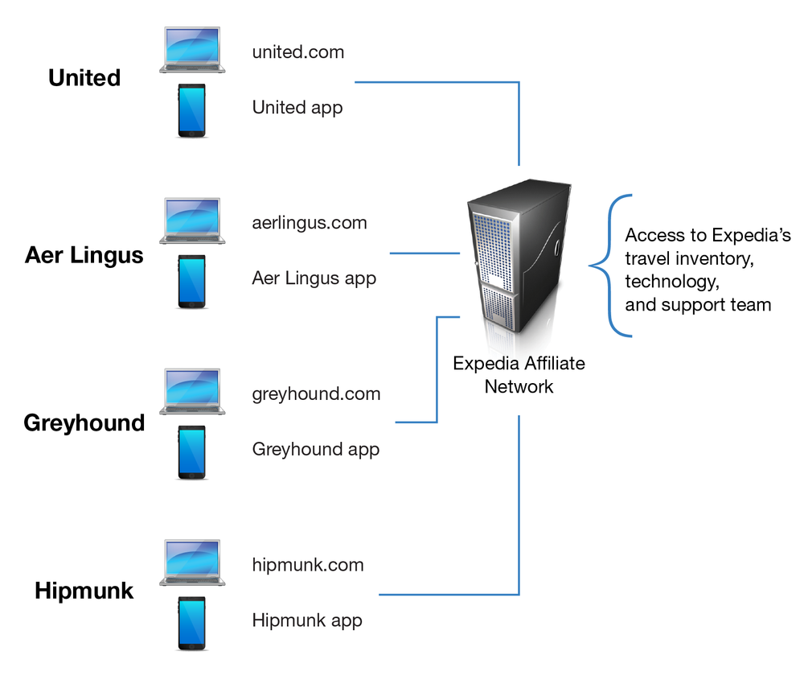
Source: John Gallaugher.
As an example of the business value of APIs in action, consider the Expedia Affiliate Network. Expedia sells a lot of travel through its own apps and website, but it realized that by sharing its inventory with partners (for a cut of the revenue), Expedia could sell even more. The Expedia Affiliate Network offers APIs that allow partner firms to integrate Expedia's technology and travel inventory into their own webites and apps. Partners that take advantage of these Expedia APIs include United, Aer Lingus, Greyhound, and travel search tool Hipmunk. These firms use the APIs so that their users can book hotel and other travel booking from within their own apps and websites, but without having to source inventory, work with suppliers, and create their own complete travel booking systems (all that’s the stuff Expedia is so good at). For partners, this can be a great deal; they get to keep customers in their websites for a greater percentage of travel needs (booked your Aer Lingus flight to Ireland at aerlingus.com? Pick out a hotel and rental car, too). The partner firm’s brand remains front and center with the customer. The partner firm continues to maintain the relationship with the customer (and gather critically important customer data), and they get a cut of Expedia’s booking revenue. For its trouble, Expedia gets distribution—many more orders than it would otherwise get through its own sites and apps. How many? About $2 billion a year, even after sharing a percentage of bookings with API-using partners!

Formats to Facilitate Sharing Data
You might hear several additional terms within the context of distributed computing, including EDI, XML, and JSON. EDI (electronic data interchange)
A set of standards for exchanging messages containing formatted data between computer applications.
is a set of standards for exchanging information between computer applications. EDI is most often used as a way to send the electronic equivalent of structured documents between different organizations. Using EDI, each element in the electronic document, such as a firm name, address, or customer number, is coded so that it can be recognized by the receiving computer program. Eliminating paper documents makes businesses faster and lowers data entry and error costs. One study showed that firms that used EDI decreased their error rates by 82 percent, and their cost of producing each document fell by up to 96 percent.
EDI is a very old standard, with roots stretching back to the 1948 Berlin Airlift. While EDI is still in use, a new generation of more-flexible technologies for specifying data standards are taking its place. The two main technologies replacing EDI are extensible markup language (XML)
A tagging language that can be used to identify data fields made available for use by other applications. Most APIs and Web services send messages where the data exchanged is wrapped in identifying XML tags.
, and JavaScript Object Notation (JSON
JavaScript Object Notation (JSON)—a popular data interchange format, JSON is a technology standard often used to format data when being sent or received via APIs.
, pronounced jay-sahn). XML has lots of uses, but in the context of distributed systems, it allows software developers to create a set of standards for common data elements that, like EDI messages, can be sent between different kinds of computers, different applications, and different organizations. Many computer programs also use XML as a way to export and import data in a common format that can be used regardless of the kind of computer hardware, operating system, or application program used. And if you design websites, you might encounter XML as part of the coding behind the Cascading Style Sheets (CSS) that help maintain a consistent look and feel to the various Web pages in a given website. XML is often thought of as easier to code than EDI, and it’s more robust because it can be extended—organizations can create formats to represent any kind of data (e.g., a common part number, photos, the complaint field collected by customer support personnel). XML was initially the go-to technology for specifying the format of data exchanged in Web services, but today’s APIs are more likely to use an even more compact and simpler standard, JSON. While the name JSON contains JavaScript (a popular programming language for client and server software development), the standard is now used in a host of languages beyond JavaScript. While a discussion of the advantages and disadvantages of each is beyond the scope of this text, managers should know that when they encounter any of these terms, they refer to standards that facilitate the data exchange that make many distributed information systems possible.
Figure 5.7 JSON and XML Examples
These examples both show an “employees” object with three employee records. The first is represented in JSON format, the second in XML.
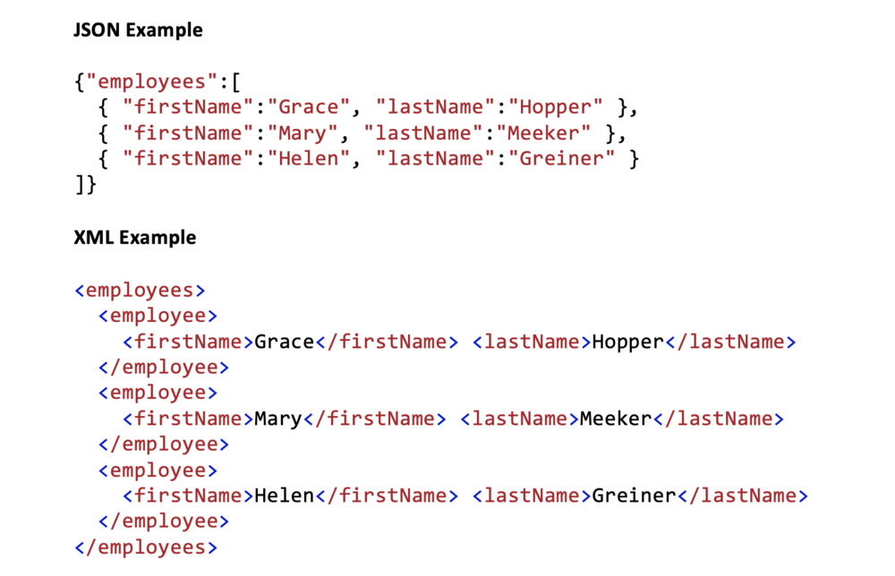
Source: Adapted from an example at W3Schools.com.
Connectivity has made our systems more productive and enables entire new strategies and business models. But these wonderful benefits come at the price of increased risk. When systems are more interconnected, opportunities for infiltration and abuse also increase. Think of it this way: Each “connection” opportunity is like adding another door to a building. The more doors that have to be defended, the more difficult security becomes. It should be no surprise that the rise of the Internet and distributed computing has led to an explosion in security losses by organizations worldwide.

Learn to Program Using Swift for iOS Development
Want to learn more? The author’s video-centric programming text: “Learn to Program Using Swift for iOS Development” introduces new-to-programming students to many concepts. By the end of the text, students are building apps accessing APIs and returning JSON, including apps that get weather data from Dark Sky, or that access databases of Star Wars movie trivia. Students also learn to use the cloud-based NoSQL database, Google Cloud Firestore to build truly social apps. Find out more at http://gallaugher.com/swift.
Figure 5.8 Building Apps Accessing APIs
The WeatherGift app on the left uses JSON data accessed from the Dark Sky API, while the Snacktacular app on the right uses the Google Cloud Firestore database to share data and accesses location data from the Google Places Autocomplete API.
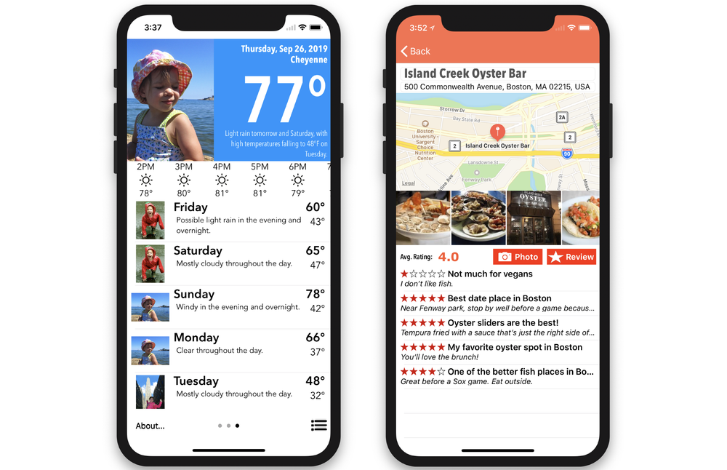
Source: John Gallaugher.

Key Takeaways
- Client-server computing is a method of distributed computing in which one program (a client) makes a request to be fulfilled by another program (a server).
- Server is a tricky term and is sometimes used to refer to hardware. While server-class hardware refers to more powerful computers designed to support multiple users, just about any PC or notebook can be configured to run server software. Many firms choose to have their server software hosted “in the cloud” on the computers of third-party firms.
- Web servers serve up websites and can perform some scripting.
- Most firms serve complex business logic from an application server.
- Isolating a system’s logic in three or more layers (presentation or user interface, business logic, and database) can allow a firm flexibility in maintenance, reusability, and in handling upgrades.
- Web services and APIs allow different applications to communicate with one another. The terms are imprecise, and you’ll often hear them used interchangeably. Web services and APIs define the method to call a piece of software (e.g., to get it to do something), and the kind of response the calling program can expect back.
- APIs and Web services make it easier to link applications as distributed systems, and can make it easier for firms to link their systems across organizations. Expedia uses APIs to expand its reach and bring in some $2 billion from revenue-sharing partners that use its technology.
- Popular messaging standards include EDI (older), XML, and JSON. Sending messages between machines instead of physical documents can speed processes, drastically cut the cost of transactions, and reduce errors.
- Distributed computing can yield enormous efficiencies in speed, error reduction, and cost savings and can create entirely new ways of doing business.
- When computers can communicate with each other (instead of people), this often results in fewer errors, time savings, and cost reductions, and can even create whole new ways of doing business.

Questions and Exercises
- Differentiate the term “server” used in a hardware context, from “server” used in a software context.
- Describe the “client-server” model of distributed computing. What products that you use would classify as leveraging client-server computing?
- How are firms using APIs to transform from being a product to being a platform? How can APIs and Web services enhance a firm’s competitive advantage?
- List the advantages that APIs have brought to Expedia and its partners.
- What are the security risks associated with connectivity, the Internet, and distributed processing?

5.5 Writing Software

Learning Objectives
- Understand, at a managerial level, what programming languages are and how software is developed.
- Recognize that an operating system and microprocessor constrain the platform upon which most compiled application software will run.
- Understand what Java is and why it is significant.
- Know what scripting languages are.
So you’ve got a great idea that you want to express in software—how do you go about creating a program? Programmers write software in a programming language
Provides the standards, syntax, statements, and instructions for writing computer software.
. While each language has its strengths and weaknesses, many commercial applications are written in a variant of the C programming language such as C++ (pronounced “see plus plus”), C# (pronounced “see sharp”), or Objective-C (the original language used for iOS app development). Visual Basic (from Microsoft) and Java (from Sun) are also among the more popular of the dozens of programming languages available. Web developers may favor specialty languages like Ruby and Python, SQL is a popular special-purpose language used in databases, R is popular for business analytics. And languages are constantly evolving. Apple has created Swift, a programming language to offer the power of Objective-C but in a language that is more powerful and feature-rich with the simplicity and error handling of leaner, easier-to-use Web programming languages. Swift is now open sourced and is used on many other platforms, including back-end server and database solutions from IBM. Apple has created many intro-to-programming products encouraging grade-schoolers to learn Swift, including Swift Playgrounds on the iPad, and a “learn to code” grade school curriculum, so expect more students to arrive at university with Swift experience. Google has also embraced and extended a Swift-like language named Kotlin, offering developers a more updated approach for Android development.
Some programming languages are extended by frameworks. These are libraries, templates, and extensions that simplify and standardize common tasks, speeding software development, reducing errors, and prompting reuse. Programmers use frameworks to use a standardized set of code and techniques that others have developed and tested, rather than requiring every developer to create his or her own code for things many others have done before them (handle database interactions, manage cookies, etc.). Examples of popular frameworks used to develop websites include Rails (for Ruby), Django (for Python), AngularJS (for JavaScript), and ASP.NET (pronounced “ay-ess-pee dot net”).
Most professional programmers use an integrated development environment (IDE)
An application that includes an editor (a sort of programmer’s word processor), debugger, and compiler, among other tools.
to write their code. The IDE includes a text editor, a debugger for sleuthing out errors, and other useful programming tools. Modern IDEs mean it’s never been easier to be a programmer. Most systems provide code-completion, which makes suggestions while you type and helps avoid typos. Real-time debuggers can catch simple, common programming mistakes made while writing code, and offer to fix them. The IDE will also compile
Step in which program code written in a language that humans can more easily understand, is then converted into a form (expressed in patterns of ones and zeros) that can be understood and executed by a microprocessor. Programmers using conventional programming languages must compile their software before making it available for execution.
a programmer’s code, turning the higher-level lines of instructions that are readable by humans into lower-level instructions expressed as the patterns of ones and zeros that are readable by a computer’s microprocessor. Many firms provide IDEs for free, in an effort to encourage software development for a platform. Popular IDEs include Xcode for Apple products, Android Studio from Google, Visual Studio from Microsoft, and several open source products, such as Eclipse and NetBeans.
Figure 5.9 Apple’s Xcode IDE
Apple’s free Xcode IDE allows anyone with a Mac to build software for iOS, Mac OS, Apple Watch, Apple TV, and more. Xcode comes with a simulator, and like most IDEs, includes an editor that makes code-completion suggestions as you type, a canvas to visually design an app, a debugger to find and correct problems, and more.
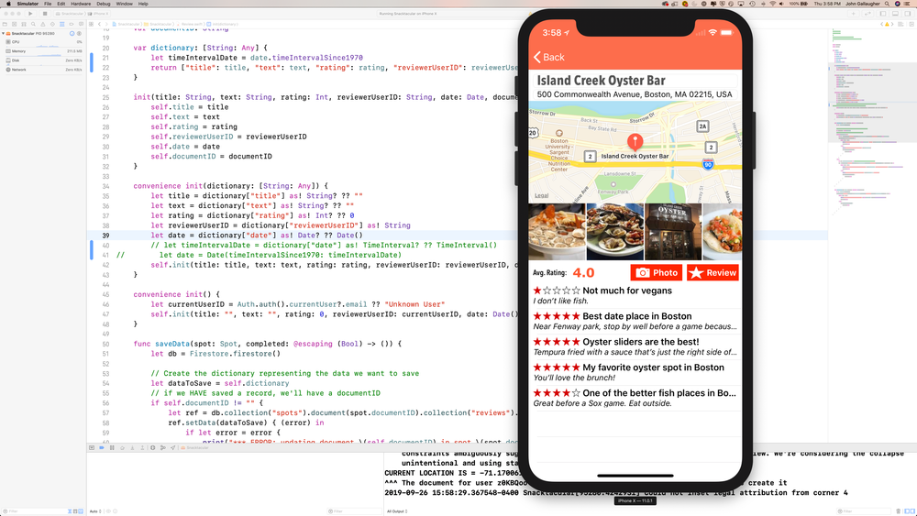
Source: Apple’s Xcode IDE.
Look at the side of a box or online order information from commercial software, and you’re likely to see system requirements that specify the operating system and processor that the software is designed for (e.g., “this software works on computers with Windows 10 and Intel-compatible processors”). Wouldn’t it be great if software could be written once and run everywhere? That was the original idea behind Java
A programming language, initially developed by Sun Microsystems, designed to provide true platform independence (“write once, run anywhere”) for application developers. In most cases, Java apps are developed to be executed by a Java Virtual Machine—an interpreting layer that translates code as it executes, into the format required by the operating system and microprocessor. Without Java, application developers have to write and compile software to execute natively by a specific operating system/microprocessor combination (e.g., Windows/Intel, Linux PowerPC, Mac/Intel, Linux/Intel).
—a programming language developed by Sun Microsystems.
Java was initially designed so that programmers didn’t write code with specific operating system commands (say for Windows, macOS, or Linux). Instead there are special Java commands to control the user interface or interact with the display and other hardware. Java programs can run on any computer that has a Java Virtual Machine (JVM), a software layer that interprets Java code so that it can be understood by the operating system and processor of a given computer. Java’s platform independence—the ability for developers to “write once, run everywhere”—is its biggest selling point. Many websites execute Java applets to run the animation you might see in advertisements or games. Java has also been deployed on billions of mobile phones worldwide, and is popular among enterprise programmers who want to be sure their programs can scale from smaller hardware up to high-end supercomputers. As long as the machine receiving the Java code has a JVM, then the Java application should run. However, Java has not been popular for desktop applications. Since Java isn’t optimized to take advantage of interface elements specific to the Mac or Windows, most Java desktop applications look clunky and unnatural. Java code that runs through the JVM interpreter is also slower than code compiled for the native OS and processor that make up a platform.
There are some caveats about the “write once, run anywhere” nature of Java. Java is also available as a language that can be compiled and executed for a specific operating system and processor, just like traditional programming languages. For example, Java is the default language for Android and some other systems. Because Android has its own standards for displaying interface elements and interacting with hardware, Java for Android “breaks” the initial “write once” promise of Java, and an Android app won’t execute on non-Android devices. Google had adopted Java because it was very popular and many people were already familiar with the language, however like Apple moving to Swift to overcome Objective-C limitations, Google has created Kotlin as a more modern alternative to Java.
Scripting languages are the final category of programming tool that we’ll cover. Scripting languages
Programming tool that executes within an application. Scripting languages are interpreted within their applications, rather than compiled to run directly by a microprocessor.
typically execute within an application. Microsoft offers a scripting language called VBScript (a derivative of Visual Basic) to automate functions in Office. And most browsers and Web servers support JavaScript, a language that helps make the Web more interactive (despite its name, JavaScript is unrelated to Java). Python is a popular language used in Web development and Big Data efforts, and R is a scripting language that is popularly used for analytics. Scripting languages are interpreted
Languages where each line of written code is converted (by a software program, called an “interpreter”) for execution at run-time. Most scripting languages are interpreted languages. Many programmers also write Java applications to be interpreted by the Java Virtual Machine.
within their applications, rather than compiled to run directly by a microprocessor. This distinction makes them slower than the kinds of development efforts found in most commercial software. But most scripting languages are usually easy to use, and are often used both by professional programmers and power users. It’s also possible to find additional products that provide some degree of compilation that speeds along certain scripting languages.

Key Takeaways
- Programs are often written in a tool called an IDE, an application that includes an editor (a sort of programmer’s word processor), debugger, and compiler, among other tools.
- Compiling takes code from the high-level language that humans can understand and converts it into the sets of ones and zeros in patterns representing instructions that microprocessors understand.
- Popular programming languages include C++, C#, Visual Basic, and Java.
- Most software is written for a platform—a combination of an operating system and microprocessor.
- Java was originally designed to be platform independent. Computers running Java have a separate layer called a Java Virtual Machine that translates (interprets) Java code so that it can be executed on an operating system/processor combination. In theory, Java written using the standards of the virtual machine should be “write once, run everywhere,” as opposed to conventional applications that are written for an operating system and compiled for an OS/processor combination.
- Some environments use the Java programming language, but “break” the write-once-run-anywhere promise by including proprietary code. This is the case with Java used for Android development. Google has its own standards for coding for the Android user interface and interacting with hardware that stand apart from what is available in the JVM, so an Android app won’t run on other devices.
- Java is popular on mobile phones and enterprise computing, and is widely used to make websites more interactive. Java has never been a successful replacement for desktop applications, largely because user interface differences among the various operating systems are too great to be easily standardized.
- Scripting languages are interpreted languages, such as Python, R, VB Script and Java Script. Many scripting languages execute within an application (like the Office programs, a Web browser, or to support the functions of a Web server). They are usually easier to program, but are limited in scope (e.g., usually not used for desktop applications) and execute more slowly than compiled languages.

Questions and Exercises
- List popular programming languages.
- What are programming frameworks, and why would you use one? Name some of the more popular programming frameworks used for web development, and name the programming languages they are used with.
- What’s an IDE? Why do programmers use IDEs? Name IDEs popular for Windows and Mac users.
- What is the difference between a compiled programming language and an interpreted programming language?
- Name one advantage and one disadvantage of scripting languages.
- In addition to computers, on what other technology has Java been deployed? Why do you suppose Java is particularly attractive for these kinds of applications?
- What’s a JVM? Why do you need it?
- What if a programmer wrote perfect Java code, but there was a bug on the JVM installed on a given computer? What might happen?
- Why would developers choose to write applications in Java? Why might they skip Java and choose another programming language?
- Why isn’t Java popular for desktop applications?
- Go to http://www.java.com. Click on “Do I have Java?” Is Java running on your computer? Which version?
- Interested in building apps? Your author has written a video-based online text to learn to program in the Swift programming language while also learning app development. The first three chapters are free. If you have a Mac you can download Apple's Xcode software and get started. Visit http://gallaugher.com/swift for more info. And if you like learning to code, encourage your university to adopt this product for a "flipped class." Students learn on their own through more than 100 video lectures and exercises, and spend classroom time on additional exercises that would be considered “homework” in a traditional class. It's never been easier for your school to offer an apps class, and if you're successful, maybe we'll profile your firm in a future version of this textbook!

5.6 Software Development Methodologies: From Waning Waterfall to Ascending Agile, plus a Sprint through Scrum

Learning Objectives
- Understand why firms use software methodologies.
- Know the benefits and weaknesses of waterfall and agile methodologies.
- Understand scrum and its various components.

A Brief Introduction to Popular Approaches to Developing Software
Firms are also well served to leverage established project planning and software development methodologies that outline critical business processes and stages when executing large-scale software development projects. The idea behind these methodologies is straightforward—why reinvent the wheel when there is an opportunity to learn from and follow blueprints used by those who have executed successful efforts? When methodologies are applied to projects that are framed with clear business goals and business metrics, and that engage committed executive leadership, success rates can improve dramatically.
Software development methodologies
Sometimes also referred to as the SDLC or software development life cycle—methods to divide tasks related to software creation and deployment up into tasks targeted at building better products with stronger product management guidelines and techniques.
(sometimes referred to as the software development lifecycle, or SDLC) are methods to divide up tasks related to software creation and deployment into tasks targeted at building better products with stronger product management guidelines and techniques. While software development methodologies are the topic of more advanced technology and project management courses, the savvy manager knows enough to inquire about the development methodologies and quality programs used to support large-scale development projects, and can use these investigations as further input when evaluating whether those overseeing large-scale efforts have what it takes to get the job done. There are many different software development methodologies, but it helps to know key terms and some key strengths and weaknesses to be better prepared for the inevitability of being involved in a software development project.
The waterfall method
A relatively linear sequential approach to software development (and other projects). Benefits include surfacing requirements up front and creating a blueprint to follow throughout a project. Often criticized for being too rigid, slow, and demanding project forethought that’s tough to completely identify early on.
(the classic, but increasingly out-of-favor approach) is a relatively linear sequential approach to software development (and other projects). There are several variants of waterfall, but most see project progress flowing in largely one direction (downwards, from one step to another, like a waterfall) through the phases often listed as: requirements identification (documenting what it will take and showing use cases), design (what technologies should be used, who are the stakeholders impacted), implementation (building the product), verification (installation, testing, debugging), and maintenance (improving quality, fixing bugs). The goal of using these steps is to clarify what needs to be done and unearth problems early, before the project is built and deployed (which, as discussed, should reduce costs). The use of upfront documentation can help prevent “feature creep
An expansion of the scope of a project.
,” or expansion of the scope of a project. And the plan helps provide strong documentation that can be helpful in future maintenance of the product.
The most significant criticism of the waterfall approach is that it is very rigid and can take a long time to implement, and requires precise forethought on all requirements needed at the end of the project. Waterfall has largely fallen out of favor, as many firms have found it restricts ongoing interaction and can take too much time, with needs in fast-changing industries shifting before a lengthy product can be completed. Waterfall has even fallen out of favor in the U.S. military, an organization often thought to use rigid planning and documentation.
While waterfall is on the way out in most organizations, the agile development
Developing work continually and iteratively, with a goal of more frequent product rollouts and constant improvement across smaller components of the larger project.
approach (and variants) has become a dominant software development methodology. Agile targets the weaknesses of waterfall, tackling work continually and iteratively, with a goal of more frequent product rollouts and constant improvement across smaller components of the larger project.Agile focuses on customer needs and organizational goals. Teams tackle smaller, targeted tasks with the hope of building products more quickly, with greater user input. Goals can evolve as needs unfold and new priorities come to the fore. Agile is popular due to its speed and flexibility. While some criticize the approach as one that might force products to develop too quickly and with less quality or documentation than classic approaches, there are several additional techniques often used in agile that target specific weaknesses, including test-driven design, behavior-driven development, pair programming, extreme programming, and refactoring. You may also hear other terms used with agile, including lean software (which provides additional methods for improved efficiency while cutting waste and excess), and scrum (which is a popular way to implement agile development).
Scrum
An approach to organizing and managing agile projects that breaks deliverables into “sprints” delivered in one- to six-week increments by teams of fewer than ten. Scrum defines functions (roles) for management and development, meetings (ceremonies), and how the process is documented and tracked (artifacts).
is an approach to organizing and managing agile projects and is worth mentioning due to its popularity. Scrum breaks projects up into tasks called sprints that are meant to be completed in one to six weeks. Scrum teams are self-organizing and work cross-functionally, with managers, developers, designers, and users in regular contact. You’ll often hear scrum described as having roles, artifacts, and ceremonies:
Roles (job functions):
- Product owner—represents the “voice of the customer,” advocates for the needs of the organization, helps in setting requirements, and is ultimately held accountable for deliverables.
- Scrum master—serves the team by running meetings, keeping teams on process, and acting as a buffer to external team distractions. The scrum master may also coach the team, work with stakeholders, and partner with the product owner to manage task priority.
- Team—often held to a small number of task-focused workers (three to nine is common). The team provides analysis, design, development, testing, documentation, and more.
Artifacts (a way of documenting work and its current state):
- Product vision—a business case for the task and value to be delivered.
- Product backlog—a collection of user stories (product features described in natural language from the user’s perspective). These describe a feature set. “As a user I need <something> so that <reason>.” These are defined by the product owner in conjunction with other stakeholders.
- Sprint backlog—the stories that are incorporated into the next sprint—e.g., what needs to be done in the next one to three weeks.
- Task board—used by many firms implementing scrum, a task board with Post-it notes that should move between columns “stories” (task requirements), “to do” (prioritized tasks, not yet started), “in-progress,” “testing,” and “done.” Others may include a burndown chart or some other variant showing products completed until reaching zero. The goal is to keep everyone on task to move “stories” from “to do” to “done” within a one-to-six-week timeline.
Ceremonies (meetings):
- Sprint planning—a team planning meeting where stories (requirements defined from user perspective) are fleshed out, and the goal and scope of the sprint is determined.
- Daily scrum—a daily stand-up team meeting (standing keeps things quick—often limited to, or “time boxed” to no more than 15 minutes), to discuss what was completed since the previous meeting, what individuals are working on, and any things that are blocked and need help. This meeting is meant to keep people in sync and on track, and to surface insights and expertise to help.
- Sprint demo and review and retrospective (sometimes separated)—demonstration by a team of completed work to product owner; discusses what worked and what can be improved for the next sprint.
Scrum in Two Minutes
A brief introduction to scrum concepts.

Key Takeaways
- Software development methodologies seek to bring planning and structure to software development projects. When methodologies are applied to projects that are framed with clear business goals and business metrics, and that engage committed executive leadership, success rates can improve dramatically.
- The waterfall methodology is a relatively linear sequential approach to software development (and other projects). Benefits include surfacing requirements up front and creating a blueprint to follow throughout a project. Waterfall is often criticized for being too rigid, slow, and demanding of project forethought that’s tough to completely identify early on.
- The agile development approach (and variants) tackles work continually and iteratively, with a goal of more frequent product rollouts and constant improvement across smaller components of the larger project. Teams tackle smaller, targeted tasks with the hope of building products more quickly, with greater user input.
- Scrum is an approach to organizing and managing agile projects and is worth mentioning due to its popularity. Scrum breaks projects up into tasks called sprints that are meant to be completed in one to six weeks. Scrum teams are self-organizing and work cross-functionally, with managers, developers, designers, and users in regular contact.

Questions and Exercises
- Interview a systems development person at your university or at another organization. Does the firm use software development methodologies? If so, do they use one approach for all projects? What factors went into their decision? What do they see as the pros and cons of each approach?
- Investigate scrum. Is it possible to get scrum training online? What alternatives have you discovered? Does this seem like something you would want to pursue? Why or why not?
- Scrum isn’t limited to technology projects. Would scrum work for projects that you are working on—including school group projects or more complex tasks in other organizations? If so, try using scrum and report back to your class with results, if you have them before semester’s end.
- Investigate some of the other approaches that are sometimes combined with agile development, such as paired programming and team programming. Would you prefer to use these approaches? Why or why not?

5.7 Beyond the Price Tag: Total Cost of Ownership and the Cost of Tech Failure

Learning Objectives
- List the different cost categories that comprise total cost of ownership.
- Understand that once a system is implemented, the costs of maintaining and supporting the system continue.
- List the reasons why technology development projects fail and the measures that can be taken to increase the probability of success.
- Examine the failed launch and eventual fix associated with HealthCare.gov, understanding the factors associated with the system’s botched rollout and techniques used to recover the effort.
Managers should recognize that there are a whole host of costs that are associated with creating and supporting an organization’s information systems. Of course, there are programming costs for custom software as well as purchase, configuration, and licensing costs for packaged software, but there’s much, much more.
There are costs associated with design and documentation (both for programmers and for users). There are also testing costs. New programs should be tested thoroughly across the various types of hardware the firm uses, and in conjunction with existing software and systems, before being deployed throughout the organization. Any errors that aren’t caught can slow down a business or lead to costly mistakes that could ripple throughout an organization and its partners. Studies have shown that errors not caught before deployment could be 100 times more costly to correct than if they were detected and corrected beforehand.
Once a system is “turned on,” the work doesn’t end there. Firms need to constantly engage in a host of activities to support the system, which may also include:
- providing training and end user support;
- collecting and relaying comments for system improvements;
- auditing systems to ensure compliance
- Ensuring that an organization’s systems operate within required legal constraints, and industry and organizational obligations.
- (i.e., that the system operates within the firm’s legal constraints and industry obligations);
- providing regular backup of critical data;
- planning for redundancy and disaster recovery in case of an outage; and
- vigilantly managing the moving target of computer security issues.
With so much to do, it’s no wonder that firms spend 70 to 80 percent of their information systems (IS) budgets just to keep their systems running. The price tag and complexity of these tasks can push some managers to think of technology as being a cost sink rather than a strategic resource. These tasks are often collectively referred to as the total cost of ownership
An economic measure of the full cost of owning a product (typically computing hardware and/or software). TCO includes direct costs such as purchase price, plus indirect costs such as training, support, and maintenance.
(TCO) of an information system. Understanding TCO is critical when making technology investment decisions. TCO is also a major driving force behind the massive tech industry changes discussed in Chapter 6 “Software in Flux: Open Source, Cloud, Virtualized, and App-Driven Shifts”.

Why Do Technology Projects Fail?
Even though information systems represent the largest portion of capital spending at most firms, an astonishing one in three technology development projects fails to be successfully deployed. Imagine if a firm lost its investment in one out of every three land purchases, or when building one in three factories. These statistics are dismal! Writing in IEEE Spectrum, risk consultant Robert Charette provides a sobering assessment of the cost of software failures, stating, “The yearly tab for failed and troubled software conservatively runs somewhere from $60 to $70 billion in the United States alone. For that money, you could launch the space shuttle one hundred times, build and deploy the entire twenty-four-satellite Global Positioning System, and develop the Boeing 777 from scratch—and still have a few billion left over.”
Why such a bad track record? Sometimes technology itself is to blame, other times it’s a failure to test systems adequately, and sometimes it’s a breakdown of process and procedures used to set specifications and manage projects. In one example, a multimillion-dollar loss on the NASA Mars Observer was traced back to a laughably simple oversight: Lockheed Martin contractors using English measurements, while the folks at NASA used the metric system. Yes, a $125 million taxpayer investment was lost because a bunch of rocket scientists failed to pay attention to third grade math. When it comes to the success or failure of technical projects, the devil really is in the details.
Projects rarely fail for just one reason. Project postmortems often point to a combination of technical, project management, and business decision blunders. The most common factors include the following:
- Poor goal setting, including a lack of clarity or ability to achieve goals
- Weak project leadership and project management
- Nonexistent or limited executive commitment
- Poorly forecast resource needs and inadequate access to required resources
- Project complexity
- “Scope Creep” or changing and increasing requirements during project development
- Ineffective project reporting and poor communication across constituents that include the project customer, end users, developers, and others in firm and IS operations
- Inappropriate technical choices, including immature technical offerings
- Inadequate testing and deployment procedures that should catch flaws before major rollout
- Internal and external politics, squabbling, and misalignment of priorities among stakeholders
- Time and delivery pressures that encourage corner cutting, ethical lapses, or other design weaknesses
Managers need to understand the complexity involved in their technology investments, and that achieving success rarely lies with the strength of the technology alone.
But there is hope. Information systems organizations can work to implement procedures to improve the overall quality of their development practices. Mechanisms for quality improvement include capability maturity model integration (CMMI)
A process-improvement approach (useful for but not limited to software engineering projects) that can assist in assessing the maturity, quality, and development of certain organizational business processes, and suggest steps for their improvement.
, which gauges an organization’s process maturity and capability in areas critical to developing and deploying technology projects, and provides a carefully chosen set of best practices and guidelines to assist quality and process improvement.

Lessons Learned from the Failure and Rescue of HealthCare.gov
To say the Affordable Care Act was controversial is an understatement. What many regard as the signature legislation of President Obama’s domestic agenda had barely passed the U.S. Senate, squeaking by with just one vote. The U.S. House of Representatives has voted at least fifty times to repeal or roll back parts of the law. But politics aside, for the law to be successful, technology needed to work, and at rollout, it didn’t.
The Affordable Care Act (a.k.a. Obamacare) called for a website, HealthCare.gov, that served as a national health care exchange where citizens could shop for, compare, and enroll in health care plans. The site would also offer subsidies for low-income enrollees and assist those eligible to sign up for Medicaid. Interest surged the first day the site went live. Over 250,000 users were said to have visited HealthCare.gov on day one. What is the total enrollment after the first day? Eight. That’s not a typo. The system implementing HealthCare.gov was so full of bugs and design flaws that it had enrolled very few people, the number of which is enough to count using your two hands. And this is for a system for which the government had agreed to pay the lead contractor $292 million.
Figure 5.10 Healthcare.gov Website
A HealthCare.gov website error message.

Source: https://i.kym-cdn.com/photos/images/original/000/641/390/ce6.jpg.
The Problems
Problems with the website could have been predicted by anyone who read the previous section. The most critical issue was a lack of clear authority. Consultants brought in to fix the problem claimed they couldn’t figure out who was in charge of the HealthCare.gov launch. What was seen after the launch were “multiple contractors bickering with one another and no one taking ownership for anything.” Technologists were also not involved in top-level planning. The president regularly ended meetings on the Affordable Care Act by saying, “I want to remind the team that this only works if the technology works.” However, no one in the meetings had any idea whether the technology worked. In fact, in the months leading up to the site’s launch, the White House health reform director kept the White House CTO (an executive who had previously launched two commercial health care firms), “off the invitation list for the planning meetings.”
Most large-scale systems will have clear stages: requirements definition, design, development, and testing phases, but consultants brought in to survey HealthCare.gov pointed out that these phases were started on top of one another, where design and development began before requirements definition was even complete.
While so-called “agile software development” methodologies allow for iterative development, they also rely on regular testing of modules developed along the way, but there were no such precautions taken with HealthCare.gov. Predeployment testing was minimal or nonexistent, and the system was implemented in a single big bang rollout. One of the executives brought in to help diagnose problems and consult on fixes was former Twitter CTO Mike Abbott. Abbott knows how to fix websites in crisis. He’s credited with getting Twitter past incessant “fail whale” site-down messages. Abbott said, “You never open a service like this to everyone at once. You open it in small concentric circles and expand”—such as one state first, then a few more—“so you can watch it, fix it and scale it.” The lack of testing also led to no credible verification on project status. The administration was so clueless to potential problems that even thirty-six hours beforehand, White House Chief of Staff Denis McDonough told a friend that “when we turn it on we’re going to knock your socks off.”
There were also several technical and design problems with the implementation of the site. It was immediately obvious that HealthCare.gov could not scale to handle national demands. At best, the site could tolerate 1,100 simultaneous users at launch, nowhere near the 50,000 to 60,000 that was expected, or the 250,000 that had been reported as visiting the first day. The site also lacked common measurement and reporting systems. Most consumer websites report data to a dashboard used by their technical staff, a summary screen that provides a quick way for engineers to measure a website’s performance, showing things like access traffic and the number of times the page was loaded, and helping to pinpoint where system problems are occurring. HealthCare.gov lacked even the most basic performance dashboard. Common practices like caching frequently accessed data (storing high-demand items in memory so databases don’t need to be repeatedly accessed) also weren’t implemented. Also, from a design perspective, the user experience was horrible. For example, consumers were required to create an account before being able to compare plans, and the registration process created a bottleneck that further exacerbated issues, increasing wait times. Using the browser’s “Back” button frequently broke the site, and users who were kicked off mid-enrollment often had to restart efforts from scratch.
The Fix
Fixing HealthCare.gov in a few weeks’ time was a daunting challenge. No one knew the extent of problems or even if the system could be saved or needed to be scrapped entirely. Fixing the site required bringing in experienced management with clear leadership authority and responsibility. The White House tapped Jeff Zients, a highly regarded businessman, who at the time was deputy director of the Office of Management and Budget. Zients had experience running large bureaucratic programs (among them the “Cash for Clunkers” effort that spurred car sales following the 2008 U.S. recession). Zients was also scheduled to take over as director of the president’s National Economic Council.
A team of seasoned technologists was also brought in to lead the system triage and site fixes. Todd Park, the White House CTO, took a front-and-center role in helping assemble the team. In addition to on-site and remote consulting from Abbott, the team harnessed the expertise of Mikey Dickerson, Google’s site reliability engineer. Dickerson was an administration ally and had taken a leave from Google in 2012 to help Obama staffers develop big data systems deemed responsible for getting out the winning vote. Also part of the effort was Gabriel Burt, CTO at Chicago-based Civis Analytics, the firm founded by many of the analytics specialists involved in the 2012 campaign. Both men showed up in October and stayed into December.
The team needed more than leadership, they needed developer commitment. Abbott said, “The first red flag you look for is whether there is a willingness by the people there to have outside help. If not, then I’d say it’s simpler to write it new than to understand the code base as it is, if the people who wrote it are not cooperating. But they were eager to cooperate.”
At times, it seemed that bureaucracy was conspiring to halt goodwill. Government regulations don’t allow for volunteers to work on government projects for sustained periods of time. So new leadership actually had to be put on the payroll of contractor QSSI as hourly workers, earning Dickerson what he reported was “a fraction” of his Google pay.
Clear priority setting, results reporting, and coordination were implemented through stand-up meetings, which are common among practitioners of agile development and popular inside the development groups of many leading tech firms and startups. In a stand-up meeting, technologists stand up (no sitting, be quick and to the point), identify a problem or a set of problems they’re facing, identify obstacles to gaining a solution, gain quick feedback from the group, then disperse to solve presented problems, reporting back at the end of the day at a recap stand-up. An open phone line would connect people working on the website at other locations. The stand-ups helped everyone feel progress toward common goals and offered coordination that early project management lacked.
The Result
The nonpartisan Congressional Budget Office (CBO) originally projected 7 million enrollees and revised that figure down to 6 million after persistent website glitches plagued HealthCare.gov. Despite what was likely the most disastrous and embarrassing rollout of a consumer-facing government technology initiative, HealthCare.gov had actually signed up over 8 million insurance users by mid-April (roughly two weeks after the original deadline, which was extended due to rollout problems).
While the system’s failure was large and public, it was by no means an anomaly. Research firm the Standish Group estimates that in the past ten years, some 94 percent of large federal information technology projects were unsuccessful: “More than half were delayed, over budget, or didn’t meet user expectations, and 41.4 percent failed completely.” The United States isn’t alone in government technology failures. The United Kingdom’s National Health Service wasted almost $20 billion to computerize medical records before eventually abandoning the project. Wise managers will learn from the lessons of HealthCare.gov.

Key Takeaways
- The care and feeding of information systems can be complex and expensive. The total cost of ownership of systems can include software development and documentation, or the purchase price and ongoing license and support fees, plus configuration, testing, deployment, maintenance, support, training, compliance auditing, security, backup, and provisions for disaster recovery. These costs are collectively referred to as TCO, or a system’s total cost of ownership.
- Information systems development projects fail at a startlingly high rate. Failure reasons can stem from any combination of technical, process, and managerial decisions.
- System errors that aren’t caught before deployment can slow down a business or lead to costly mistakes that could ripple throughout an organization. Studies have shown that errors not caught before deployment could be 100 times more costly to correct than if they were detected and corrected beforehand.
- Firms spend 70 percent to 80 percent of their IS budgets just to keep their systems running.
- IS organizations can employ project planning and software development methodologies to implement procedures and to improve the overall quality of their development practices.
- IS organizations can leverage software development methodologies to improve their systems development procedures, and firms can strive to improve the overall level of procedures used in the organization through models like CMMI. However, it’s also critical to engage committed executive leadership in projects, and to frame projects using business metrics and outcomes to improve the chance of success.
- A combination of managerial and technical issues conspired to undermine the rollout of HealthCare.gov. While the website was effectively unusable at launch, a systematic effort of management authority, communication, coordination, and expertise rescued the effort, allowing the site to exceed enrollment projections.

Questions and Exercises
- Search online for examples of failed information systems development efforts. Come to class prepared to describe the failure, give its size and scope, the perceived reasons for the failure, and what managers could have done to prevent this failure. As a class, see if any key takeaways emerge. Are there any examples highlighting issues not mentioned in this chapter? If so, tweet links to any articles to #BizTechBook.
- Healthcare.gov was clearly botched at the start. Some have claimed this suggests private enterprise is better suited to lead such projects than the government, but are there examples of corporations that have failed, as well? Are there any additional takeaways that would help both government planners as well as corporate managers?

